Principles of Software Design
Read
Courses

Prerequisites –
- Software design process
- Software design process | Set 2
- Modern principles of software development
Design means to draw or plan something to show the look, functions and working of it.
Software Design is also a process to plan or convert the software requirements into a step that are needed to be carried out to develop a software system. There are several principles that are used to organize and arrange the structural components of Software design. Software Designs in which these principles are applied affect the content and the working process of the software from the beginning.
These principles are stated below :
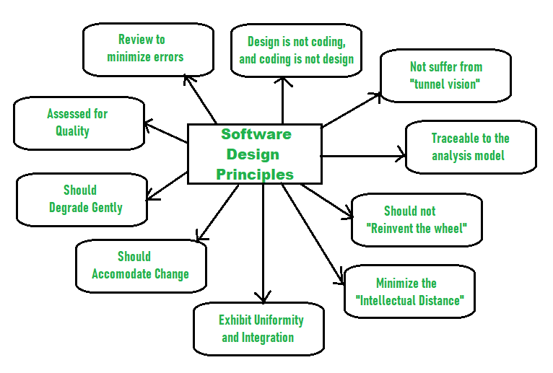
Principles Of Software Design :
- Should not suffer from “Tunnel Vision” –
While designing the process, it should not suffer from “tunnel vision” which means that is should not only focus on completing or achieving the aim but on other effects also.

- Traceable to analysis model –
The design process should be traceable to the analysis model which means it should satisfy all the requirements that software requires to develop a high-quality product.

- Should not “Reinvent The Wheel” –
The design process should not reinvent the wheel that means it should not waste time or effort in creating things that already exist. Due to this, the overall development will get increased.

- Minimize Intellectual distance –
The design process should reduce the gap between real-world problems and software solutions for that problem meaning it should simply minimize intellectual distance.

- Exhibit uniformity and integration –
The design should display uniformity which means it should be uniform throughout the process without any change. Integration means it should mix or combine all parts of software i.e. subsystems into one system.

- Accommodate change –
The software should be designed in such a way that it accommodates the change implying that the software should adjust to the change that is required to be done as per the user’s need.

- Degrade gently –
The software should be designed in such a way that it degrades gracefully which means it should work properly even if an error occurs during the execution.

- Assessed or quality –
The design should be assessed or evaluated for the quality meaning that during the evaluation, the quality of the design needs to be checked and focused on.

- Review to discover errors –
The design should be reviewed which means that the overall evaluation should be done to check if there is any error present or if it can be minimized.

- Design is not coding and coding is not design –
Design means describing the logic of the program to solve any problem and coding is a type of language that is used for the implementation of a design.
There are some modern principles for the development of software. By following these modern principles we can develop an efficacious software meeting all the needs of customer. To develop a proper software one should follow the following 10 Principles of software development:
Principles Of Software development:
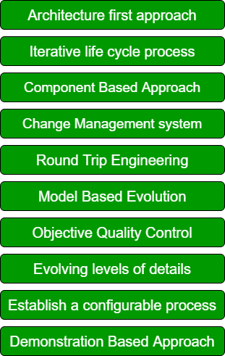
These are explained as following below.
- Architecture first approach:
In this approach over the main aim is to build a strong architecture for our software. All the ambiguities and flaws are being identified during the very trivial phase. Also, we can take all the decisions regarding the design of the software which will enhance the productivity of our software.

- Iterative life cycle process:
An iterative life cycle process we repeated the process again and again to eliminate the risk factors. An iterative life cycle we mainly have four steps requirement gathering, design, implementation, and testing. All these steps are repeated again and again until we mitigate the risk factor. Iterative life cycle process is important to alleviate risk at an early stage by repeating the above-mentioned steps again and again.

- Component Based Approach:
In component-based approach is a widely used and successful approach in which we reuse the previously defined functions for the software development. We reuse the part of code in the form of components. Component-based UI Development Optimizes the Requirements & Design Process and thus is one of the important modern software principle.

- Change Management system:
Change Management is the process responsible for managing all changes. The main aim of change management is to improve the quality of software by performing necessary changes. All changes implemented are then tested and certified.

- Round Trip Engineering:
In round trip engineering code generation and reverse engineering take place at the same time in a dynamic environment. Both components are integrated so that developers can easily work on both of them. In round trip engineering, the main characteristic is automatic update of artifacts.

- Model Based Evolution:
Model-based evolution is an important principle of software development. A model-based approach supports the evolution of graphics and textual notions.

- Objective Quality Control:
The objective of quality control is to improve the quality of our software. It involves Quality management plan, Quality metrics, Quality checklist, Quality baseline, and Quality Improvement measures.

- Evolving levels of details:
Plan intermediate releases in groups of usage scenarios with evolving levels of details. We must plan an incremental realize in which we have an evolving level of use case, architecture, and details.

- Establish a configurable process:
Establish a configurable process that is economically scalable. One single process is not suitable for all the development so we must use a configurable process which can deal with various applications.

- Demonstration Based approach:
In this approach, we mainly focus on demonstration. It helps in the increase of productivity and quality of our software by representing a clear description about problem domain, approaches used and the solution.

